**RADF POSTER EXAMPLE**

***(BRIEF EXPLAINATION OF THE EVENT)***

**DATE:**

**TIME:**

**LOCATION:**

**COST:**

**PROGRAM CONTACT:**

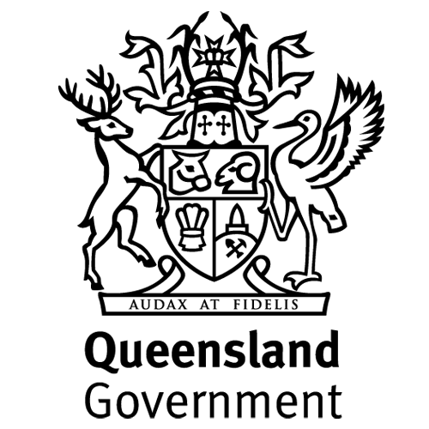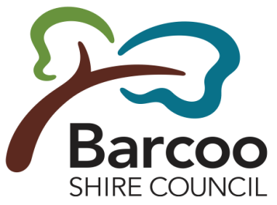

***The Regional Arts Development Fund (RADF) is a partnership between the Queensland Government and Barcoo Shire Council to support local arts and culture in regional Queensland.***