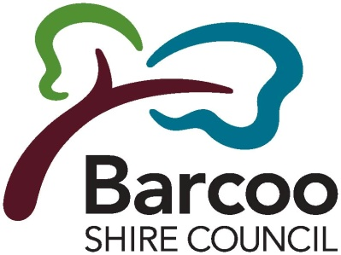
Barcoo Shire Council
ABN 34668298330 6 Perkins Street Po Box 14
Jundah Qld 4736
T: 07 46586900
F: 07 46586137
E: shire@barcoo.qld.gov.au
W: www.barcoo.qld.gov.au

WATER CONNECTION FORM

This form is to be completed when making a complaint about the Water Supply in accordance with the Barcoo Shire Council Customer Service Standards – Water Supply. The fee is $300 for each individual new water connection for either Raw Water or Treated Water connections.

OWNERS DETAILS
Owner’s Name:
Owner’s Address:
Contact Number:
Date: | / / |  |  |  |  |  | Time: | AM / PM
CONNECTION TYPE: (Please tick box)
□ Existing Connection |  |  |  | □ New Connection
CONNECTION DETAILS: (Please tick box)
□ Treated Water Supply |  |  |  | □ Raw Water Supply
□ Other (Please Specify):
PURPOSE FOR CONNECTION OR ALTERATION:
□ Connecting a new water supply |  |  |  |  | □ Alter existing water supply
□ Disconnecting an existing water supply |  |  |  |  | □
LOCATION OF CONNECTION: (Please detail street address/ premises)
ASSESSMENT NUMBER:
SIZE OF SUPPLY PIPE AND NUMBER OF POINTS:
THIS SERVICE WILL BE REQUIRED ON OR ABOUT: (Please detail date and time)
SIGNATURE OF THE OWNER OR AUTHORISED PERSON:
Please submit this form along with any additional information attached to the back and return to the Barcoo Shire Office using the contact methods provided on the top right corner of this form.
OFFICE USE ONLY:
Received in Office by: |  | Date: / / Time: AM/ PM
Payment Receipt Number: |  | Date: / /
Responsible Officer:
PRIVATE WORKS NUMBER:
Job Completed by: |  |  |  |  |  | Signature:
Job Completion Date: |  | Date: / / Time: AM/PM

